**Assignment 3**

# Pre-Homework

1.

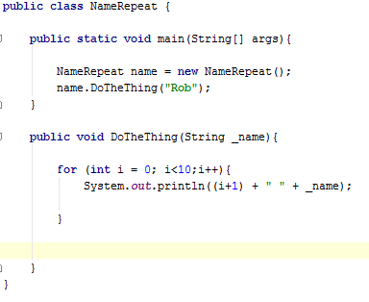

2.

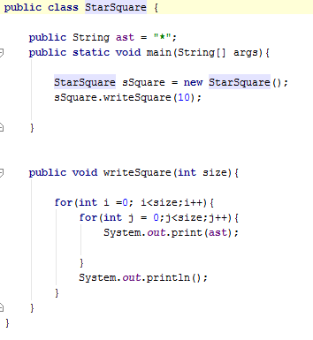

3.

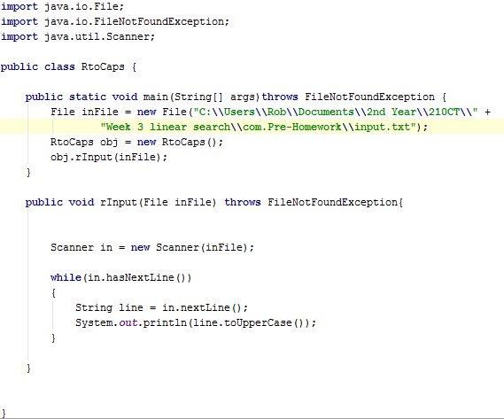

# Homework

1. Pseudocode of a linear search

BOOL LINEAR-SEARCH ( ITEM, LIST[ ])

for i ← 0 to Length[ LIST[] ]

if ( LIST[ i ] = ITEM)

return true

return false

1. Pseudocode for finding duplicates in a list

BOOLEAN EXAMINEFORDUPLICATES (LIST[])

for i ← 1 to Length[LIST]

for j ← i+1 to Length[LIST]

if LIST[i] = LIST[j]

return true

return false